**Attend an informative talk on**

**GLOBAL POSITIONING SYSTEM (GPS)**

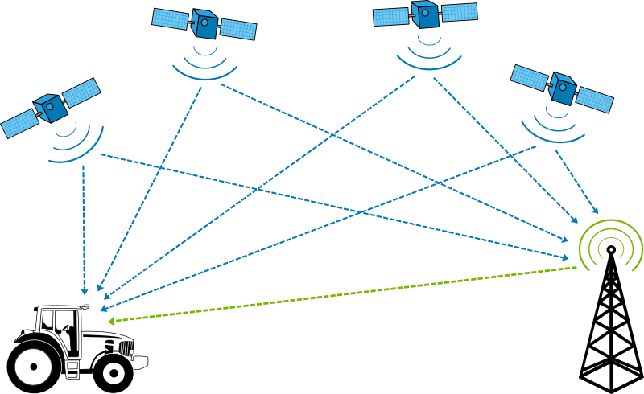

**About the Speaker**

[*XYZ*](http://mason.gmu.edu/~falsheh2/index.html)

*Mr. XYZ is a student of Fundamentals of Computing at School of Engineering, ABC, USA*

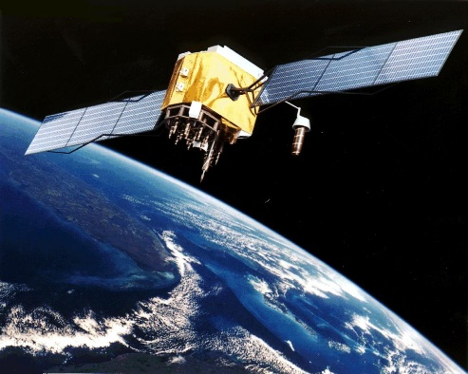

**Who Should Attend?**

*Business, Geography and IT students who are interested to know about the incredibly accurate source of quality geographical information and its processing*

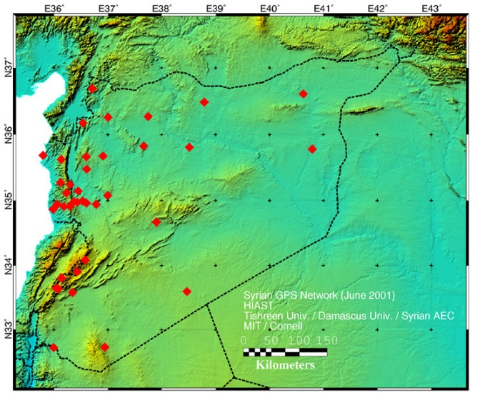

**What will it Cover?**

* *Introduction to GPS system*
* *Components of GPS system*
* *Potential application areas*